Docker Promotional pipeline with k8s

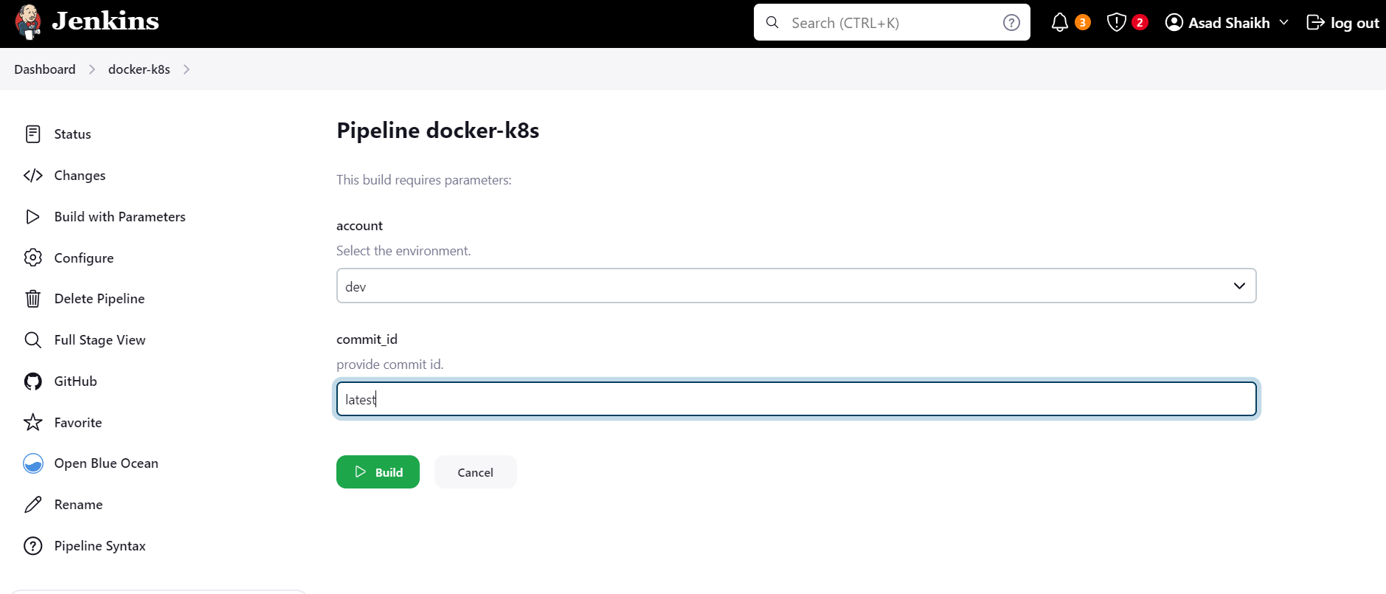

logs—

Started by user [Asad Shaikh](http://localhost:8080/user/admin)

Obtained Jenkinsfile from git git@github.com:asadis7171/jenkins-k8s.git

[Pipeline] Start of Pipeline

[Pipeline] node

Running on [Jenkins](http://localhost:8080/computer/(built-in)/) in /var/jenkins_home/workspace/docker-k8s

[Pipeline] {

[Pipeline] stage

[Pipeline] { (Declarative: Checkout SCM)

[Pipeline] checkout

Selected Git installation does not exist. Using Default

The recommended git tool is: NONE

using credential asad.pem

Cloning the remote Git repository

Cloning repository git@github.com:asadis7171/jenkins-k8s.git

> /usr/bin/git init /var/jenkins_home/workspace/docker-k8s # timeout=10

Fetching upstream changes from git@github.com:asadis7171/jenkins-k8s.git

> /usr/bin/git --version # timeout=10

> git --version # 'git version 2.39.2'

using GIT_SSH to set credentials my private key

Verifying host key using known hosts file

> /usr/bin/git fetch --tags --force --progress -- git@github.com:asadis7171/jenkins-k8s.git +refs/heads/*:refs/remotes/origin/* # timeout=10

> /usr/bin/git config remote.origin.url git@github.com:asadis7171/jenkins-k8s.git # timeout=10

> /usr/bin/git config --add remote.origin.fetch +refs/heads/*:refs/remotes/origin/* # timeout=10

Avoid second fetch

> /usr/bin/git rev-parse refs/remotes/origin/master^{commit} # timeout=10

Checking out Revision 305da954df40f01dcd793e5b07f928701f57e209 (refs/remotes/origin/master)

> /usr/bin/git config core.sparsecheckout # timeout=10

> /usr/bin/git checkout -f 305da954df40f01dcd793e5b07f928701f57e209 # timeout=10

Commit message: " added PDF file"

> /usr/bin/git rev-list --no-walk 305da954df40f01dcd793e5b07f928701f57e209 # timeout=10

[Pipeline] }

[Pipeline] // stage

[Pipeline] withEnv

[Pipeline] {

[Pipeline] withEnv

[Pipeline] {

[Pipeline] stage

[Pipeline] { (Docker Image Build IN Dev)

[Pipeline] echo

Building Docker Image Logging in to Docker Hub & Pushing the Image

[Pipeline] script

[Pipeline] {

[Pipeline] isUnix

[Pipeline] withEnv

[Pipeline] {

[Pipeline] sh

+ docker build -t asadis7171/dev:305da954df40f01dcd793e5b07f928701f57e209 .

#0 building with "default" instance using docker driver

#1 [internal] load build definition from Dockerfile

#1 transferring dockerfile: 132B done

#1 DONE 0.0s

#2 [internal] load metadata for docker.io/library/nginx:alpine

#2 ...

#3 [auth] library/nginx:pull token for registry-1.docker.io

#3 DONE 0.0s

#2 [internal] load metadata for docker.io/library/nginx:alpine

#2 DONE 24.3s

#4 [internal] load .dockerignore

#4 transferring context: 2B done

#4 DONE 0.0s

#5 [1/3] FROM docker.io/library/nginx:alpine@sha256:31bad00311cb5eeb8a6648beadcf67277a175da89989f14727420a80e2e76742

#5 DONE 0.0s

#6 [internal] load build context

#6 transferring context: 469B done

#6 DONE 0.0s

#7 [2/3] COPY default.conf /etc/nginx/conf.d/

#7 CACHED

#8 [3/3] COPY index.html /usr/share/nginx/html/

#8 CACHED

#9 exporting to image

#9 exporting layers done

#9 writing image sha256:083bc2f1bca5f5305c612dd5df39dff5b67e54fc042c3b877d265c3a8f00f13c done

#9 naming to docker.io/asadis7171/dev:305da954df40f01dcd793e5b07f928701f57e209 done

#9 DONE 0.0s

[Pipeline] }

[Pipeline] // withEnv

[Pipeline] withEnv

[Pipeline] {

[Pipeline] withDockerRegistry

Using the existing docker config file.Removing blacklisted property: auths$ docker login -u asadis7171 -p ******** <https://registry.hub.docker.com/asadis7171/dev>

WARNING! Using --password via the CLI is insecure. Use --password-stdin.

WARNING! Your password will be stored unencrypted in /var/jenkins_home/workspace/docker-k8s@tmp/6f9d9b6e-8575-45b8-a9e3-b5f8de9fd445/config.json.

Configure a credential helper to remove this warning. See

<https://docs.docker.com/engine/reference/commandline/login/#credentials-store>

Login Succeeded

[Pipeline] {

[Pipeline] isUnix

[Pipeline] withEnv

[Pipeline] {

[Pipeline] sh

+ docker tag asadis7171/dev:305da954df40f01dcd793e5b07f928701f57e209 registry.hub.docker.com/asadis7171/dev:305da954df40f01dcd793e5b07f928701f57e209

[Pipeline] }

[Pipeline] // withEnv

[Pipeline] isUnix

[Pipeline] withEnv

[Pipeline] {

[Pipeline] sh

+ docker push registry.hub.docker.com/asadis7171/dev:305da954df40f01dcd793e5b07f928701f57e209

The push refers to repository [registry.hub.docker.com/asadis7171/dev]

80fd5dd35c9c: Preparing

69a57b78b0ee: Preparing

13c52683b537: Preparing

337b7d64083b: Preparing

cdd311f34c29: Preparing

3e8ad8bcb0ac: Preparing

74b4ff8dbbd1: Preparing

c018a48a857c: Preparing

0f73163669d4: Preparing

aedc3bda2944: Preparing

c018a48a857c: Waiting

3e8ad8bcb0ac: Waiting

0f73163669d4: Waiting

74b4ff8dbbd1: Waiting

aedc3bda2944: Waiting

337b7d64083b: Layer already exists

80fd5dd35c9c: Layer already exists

cdd311f34c29: Layer already exists

13c52683b537: Layer already exists

69a57b78b0ee: Layer already exists

0f73163669d4: Layer already exists

74b4ff8dbbd1: Layer already exists

c018a48a857c: Layer already exists

aedc3bda2944: Layer already exists

3e8ad8bcb0ac: Layer already exists

305da954df40f01dcd793e5b07f928701f57e209: digest: sha256:a0ee67e8db4f1c702a6a588cfb9916bfc1a1ed37f091af10d9d799a7a3ae641e size: 2403

[Pipeline] }

[Pipeline] // withEnv

[Pipeline] }

[Pipeline] // withDockerRegistry

[Pipeline] }

[Pipeline] // withEnv

[Pipeline] }

[Pipeline] // script

[Pipeline] }

[Pipeline] // stage

[Pipeline] stage

[Pipeline] { (Pull Tag push to QA)

Stage "Pull Tag push to QA" skipped due to when conditional

[Pipeline] }

[Pipeline] // stage

[Pipeline] stage

[Pipeline] { (Pull Tag push to stage)

Stage "Pull Tag push to stage" skipped due to when conditional

[Pipeline] }

[Pipeline] // stage

[Pipeline] stage

[Pipeline] { (Pull Tag push to Prod)

Stage "Pull Tag push to Prod" skipped due to when conditional

[Pipeline] }

[Pipeline] // stage

[Pipeline] stage

[Pipeline] { (Deploy to Dev K8S cluster )

[Pipeline] withEnv

[Pipeline] {

[Pipeline] script

[Pipeline] {

[Pipeline] echo

Deploying on Dev K8S Cluster.

[Pipeline] withKubeConfig

[Pipeline] {

[Pipeline] sh

+ sed -i -e s/{{ACCOUNT}}/dev/g -e s/{{COMMITID}}/305da954df40f01dcd793e5b07f928701f57e209/g KUBE/deployment.yaml

[Pipeline] sh

+ echo deployment.yaml file after replace with sed

deployment.yaml file after replace with sed

[Pipeline] sh

+ cat KUBE/deployment.yaml

apiVersion: apps/v1

kind: Deployment

metadata:

name: nginx-jenkins-deployment

spec:

replicas: 2

selector:

matchLabels:

app: nginx-jenkins

template:

metadata:

labels:

app: nginx-jenkins

spec:

containers:

- name: nginx-jenkins-c

image: asadis7171/dev:305da954df40f01dcd793e5b07f928701f57e209

ports:

- containerPort: 80

[Pipeline] sh

+ kubectl apply -f KUBE/deployment.yaml

deployment.apps/nginx-jenkins-deployment created

[Pipeline] sh

+ kubectl apply -f KUBE/service.yaml

service/frontend-service created

[Pipeline] }

[kubernetes-cli] kubectl configuration cleaned up

[Pipeline] // withKubeConfig

[Pipeline] }

[Pipeline] // script

[Pipeline] }

[Pipeline] // withEnv

[Pipeline] }

[Pipeline] // stage

[Pipeline] stage

[Pipeline] { (Declarative: Post Actions)

[Pipeline] echo

Deleting Workspace from shared Lib

[Pipeline] deleteDir

[Pipeline] }

[Pipeline] // stage

[Pipeline] }

[Pipeline] // withEnv

[Pipeline] }

[Pipeline] // withEnv

[Pipeline] }

[Pipeline] // node

[Pipeline] End of Pipeline

Finished: SUCCESS

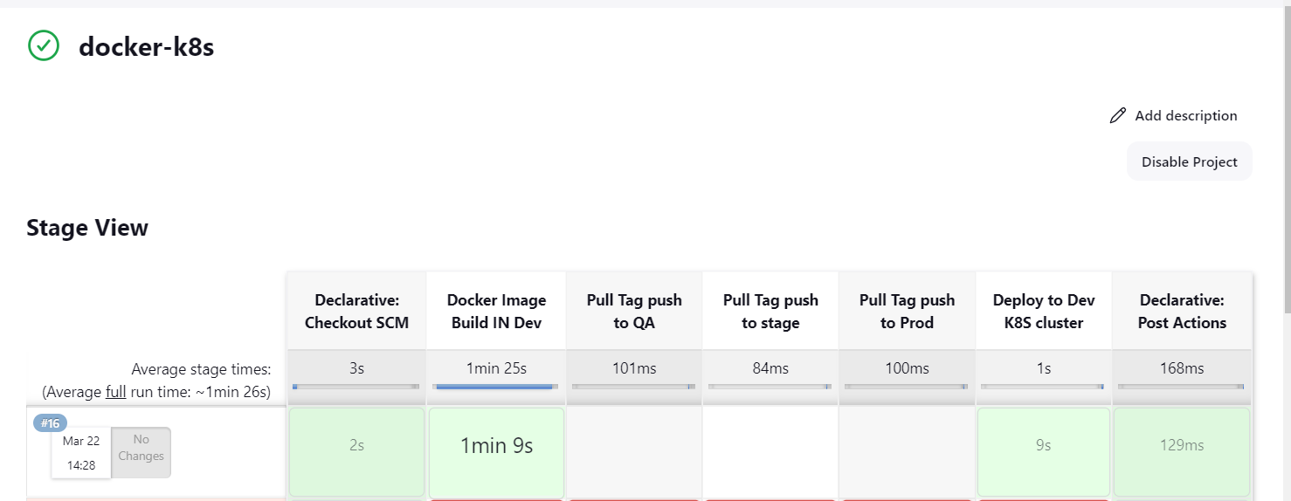

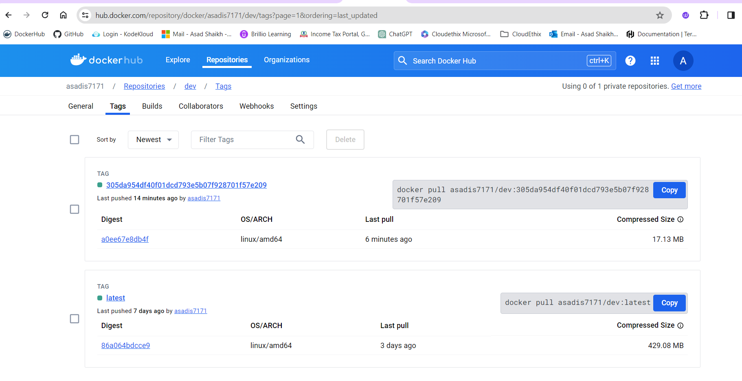

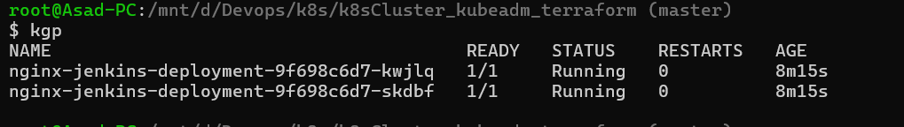

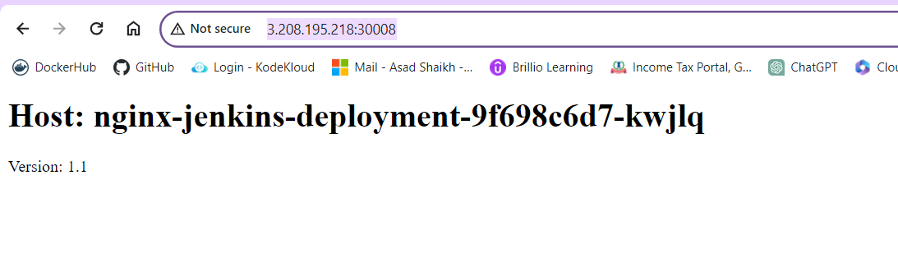

Now deploying same on QA Environment

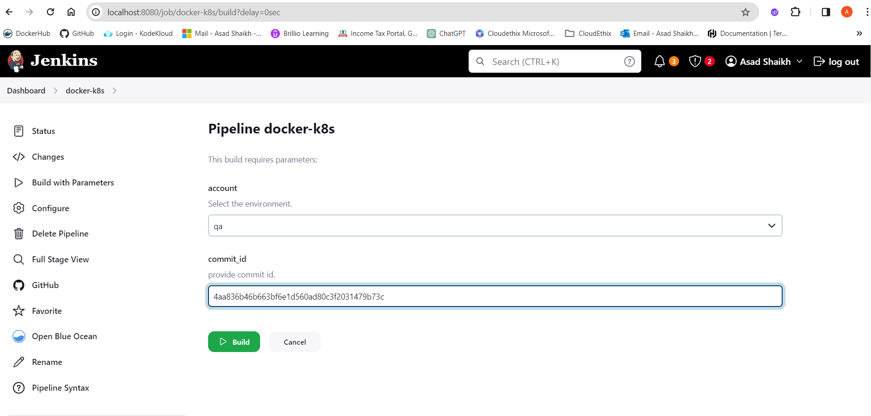

logs

Started by user [Asad Shaikh](http://localhost:8080/user/admin)

Obtained Jenkinsfile from git git@github.com:asadis7171/jenkins-k8s.git

[Pipeline] Start of Pipeline

[Pipeline] node

Running on [Jenkins](http://localhost:8080/computer/(built-in)/) in /var/jenkins_home/workspace/docker-k8s

[Pipeline] {

[Pipeline] stage

[Pipeline] { (Declarative: Checkout SCM)

[Pipeline] checkout

Selected Git installation does not exist. Using Default

The recommended git tool is: NONE

using credential asad.pem

Cloning the remote Git repository

Cloning repository git@github.com:asadis7171/jenkins-k8s.git

> /usr/bin/git init /var/jenkins_home/workspace/docker-k8s # timeout=10

Fetching upstream changes from git@github.com:asadis7171/jenkins-k8s.git

> /usr/bin/git --version # timeout=10

> git --version # 'git version 2.39.2'

using GIT_SSH to set credentials my private key

Verifying host key using known hosts file

> /usr/bin/git fetch --tags --force --progress -- git@github.com:asadis7171/jenkins-k8s.git +refs/heads/*:refs/remotes/origin/* # timeout=10

> /usr/bin/git config remote.origin.url git@github.com:asadis7171/jenkins-k8s.git # timeout=10

> /usr/bin/git config --add remote.origin.fetch +refs/heads/*:refs/remotes/origin/* # timeout=10

Avoid second fetch

> /usr/bin/git rev-parse refs/remotes/origin/master^{commit} # timeout=10

Checking out Revision 4aa836b46b663bf6e1d560ad80c3f2031479b73c (refs/remotes/origin/master)

> /usr/bin/git config core.sparsecheckout # timeout=10

> /usr/bin/git checkout -f 4aa836b46b663bf6e1d560ad80c3f2031479b73c # timeout=10

Commit message: " added PDF file"

> /usr/bin/git rev-list --no-walk 4aa836b46b663bf6e1d560ad80c3f2031479b73c # timeout=10

[Pipeline] }

[Pipeline] // stage

[Pipeline] withEnv

[Pipeline] {

[Pipeline] withEnv

[Pipeline] {

[Pipeline] stage

[Pipeline] { (Docker Image Build IN Dev)

Stage "Docker Image Build IN Dev" skipped due to when conditional

[Pipeline] }

[Pipeline] // stage

[Pipeline] stage

[Pipeline] { (Pull Tag push to QA)

[Pipeline] script

[Pipeline] {

[Pipeline] withEnv

[Pipeline] {

[Pipeline] withDockerRegistry

Using the existing docker config file.Removing blacklisted property: auths$ docker login -u asadis7171 -p ******** <https://registry.hub.docker.com/asadis7171/dev>

WARNING! Using --password via the CLI is insecure. Use --password-stdin.

WARNING! Your password will be stored unencrypted in /var/jenkins_home/workspace/docker-k8s@tmp/b5c33109-cd51-4f96-9896-2ff0e2ab161c/config.json.

Configure a credential helper to remove this warning. See

<https://docs.docker.com/engine/reference/commandline/login/#credentials-store>

Login Succeeded

[Pipeline] {

[Pipeline] isUnix

[Pipeline] withEnv

[Pipeline] {

[Pipeline] sh

+ docker pull registry.hub.docker.com/asadis7171/dev:4aa836b46b663bf6e1d560ad80c3f2031479b73c

4aa836b46b663bf6e1d560ad80c3f2031479b73c: Pulling from asadis7171/dev

Digest: sha256:a0ee67e8db4f1c702a6a588cfb9916bfc1a1ed37f091af10d9d799a7a3ae641e

Status: Image is up to date for registry.hub.docker.com/asadis7171/dev:4aa836b46b663bf6e1d560ad80c3f2031479b73c

registry.hub.docker.com/asadis7171/dev:4aa836b46b663bf6e1d560ad80c3f2031479b73c

[Pipeline] }

[Pipeline] // withEnv

[Pipeline] }

[Pipeline] // withDockerRegistry

[Pipeline] }

[Pipeline] // withEnv

[Pipeline] sh

+ echo Image pulled from DEV

Image pulled from DEV

[Pipeline] sh

+ echo Tagging Docker image from Dev to QA

Tagging Docker image from Dev to QA

[Pipeline] sh

+ docker tag asadis7171/dev:4aa836b46b663bf6e1d560ad80c3f2031479b73c registry.hub.docker.com/asadis7171/qa:4aa836b46b663bf6e1d560ad80c3f2031479b73c

[Pipeline] withEnv

[Pipeline] {

[Pipeline] withDockerRegistry

Using the existing docker config file.Removing blacklisted property: auths$ docker login -u asadis7171 -p ******** <https://registry.hub.docker.com/asadis7171/qa>

WARNING! Using --password via the CLI is insecure. Use --password-stdin.

WARNING! Your password will be stored unencrypted in /var/jenkins_home/workspace/docker-k8s@tmp/5bf75dca-52ae-4371-9a0d-1612d9bef04e/config.json.

Configure a credential helper to remove this warning. See

<https://docs.docker.com/engine/reference/commandline/login/#credentials-store>

Login Succeeded

[Pipeline] {

[Pipeline] isUnix

[Pipeline] withEnv

[Pipeline] {

[Pipeline] sh

+ docker tag registry.hub.docker.com/asadis7171/qa:4aa836b46b663bf6e1d560ad80c3f2031479b73c registry.hub.docker.com/asadis7171/qa:4aa836b46b663bf6e1d560ad80c3f2031479b73c

[Pipeline] }

[Pipeline] // withEnv

[Pipeline] isUnix

[Pipeline] withEnv

[Pipeline] {

[Pipeline] sh

+ docker push registry.hub.docker.com/asadis7171/qa:4aa836b46b663bf6e1d560ad80c3f2031479b73c

The push refers to repository [registry.hub.docker.com/asadis7171/qa]

80fd5dd35c9c: Preparing

69a57b78b0ee: Preparing

13c52683b537: Preparing

337b7d64083b: Preparing

cdd311f34c29: Preparing

3e8ad8bcb0ac: Preparing

74b4ff8dbbd1: Preparing

c018a48a857c: Preparing

0f73163669d4: Preparing

aedc3bda2944: Preparing

c018a48a857c: Waiting

74b4ff8dbbd1: Waiting

0f73163669d4: Waiting

3e8ad8bcb0ac: Waiting

aedc3bda2944: Waiting

80fd5dd35c9c: Layer already exists

337b7d64083b: Layer already exists

cdd311f34c29: Layer already exists

13c52683b537: Layer already exists

69a57b78b0ee: Layer already exists

0f73163669d4: Layer already exists

aedc3bda2944: Layer already exists

74b4ff8dbbd1: Layer already exists

3e8ad8bcb0ac: Layer already exists

c018a48a857c: Layer already exists

4aa836b46b663bf6e1d560ad80c3f2031479b73c: digest: sha256:a0ee67e8db4f1c702a6a588cfb9916bfc1a1ed37f091af10d9d799a7a3ae641e size: 2403

[Pipeline] }

[Pipeline] // withEnv

[Pipeline] }

[Pipeline] // withDockerRegistry

[Pipeline] }

[Pipeline] // withEnv

[Pipeline] sh

+ echo Image pushed

Image pushed

[Pipeline] }

[Pipeline] // script

[Pipeline] }

[Pipeline] // stage

[Pipeline] stage

[Pipeline] { (Pull Tag push to stage)

Stage "Pull Tag push to stage" skipped due to when conditional

[Pipeline] }

[Pipeline] // stage

[Pipeline] stage

[Pipeline] { (Pull Tag push to Prod)

Stage "Pull Tag push to Prod" skipped due to when conditional

[Pipeline] }

[Pipeline] // stage

[Pipeline] stage

[Pipeline] { (Deploy to Dev K8S cluster )

Stage "Deploy to Dev K8S cluster " skipped due to when conditional

[Pipeline] }

[Pipeline] // stage

[Pipeline] stage

[Pipeline] { (Deploy to QA K8S cluster )

[Pipeline] withEnv

[Pipeline] {

[Pipeline] script

[Pipeline] {

[Pipeline] echo

Deploying on QA K8S Cluster.

[Pipeline] withKubeConfig

[Pipeline] {

[Pipeline] sh

+ sed -i -e s/{{ACCOUNT}}/qa/g -e s/{{COMMITID}}/4aa836b46b663bf6e1d560ad80c3f2031479b73c/g KUBE/deployment.yaml

[Pipeline] sh

+ echo deployment.yaml file after replace with sed

deployment.yaml file after replace with sed

[Pipeline] sh

+ cat KUBE/deployment.yaml

apiVersion: apps/v1

kind: Deployment

metadata:

name: nginx-jenkins-deployment

spec:

replicas: 2

selector:

matchLabels:

app: nginx-jenkins

template:

metadata:

labels:

app: nginx-jenkins

spec:

containers:

- name: nginx-jenkins-c

image: asadis7171/qa:4aa836b46b663bf6e1d560ad80c3f2031479b73c

ports:

- containerPort: 80

[Pipeline] sh

+ kubectl apply -f KUBE/deployment.yaml

deployment.apps/nginx-jenkins-deployment configured

[Pipeline] sh

+ kubectl apply -f KUBE/service.yaml

service/frontend-service unchanged

[Pipeline] }

[kubernetes-cli] kubectl configuration cleaned up

[Pipeline] // withKubeConfig

[Pipeline] }

[Pipeline] // script

[Pipeline] }

[Pipeline] // withEnv

[Pipeline] }

[Pipeline] // stage

[Pipeline] stage

[Pipeline] { (Deploy to STAGE K8S cluster )

Stage "Deploy to STAGE K8S cluster " skipped due to when conditional

[Pipeline] }

[Pipeline] // stage

[Pipeline] stage

[Pipeline] { (Deploy to Prod K8S cluster )

Stage "Deploy to Prod K8S cluster " skipped due to when conditional

[Pipeline] }

[Pipeline] // stage

[Pipeline] stage

[Pipeline] { (Declarative: Post Actions)

[Pipeline] echo

Deleting Workspace from shared Lib

[Pipeline] deleteDir

[Pipeline] }

[Pipeline] // stage

[Pipeline] }

[Pipeline] // withEnv

[Pipeline] }

[Pipeline] // withEnv

[Pipeline] }

[Pipeline] // node

[Pipeline] End of Pipeline

Finished: SUCCESS

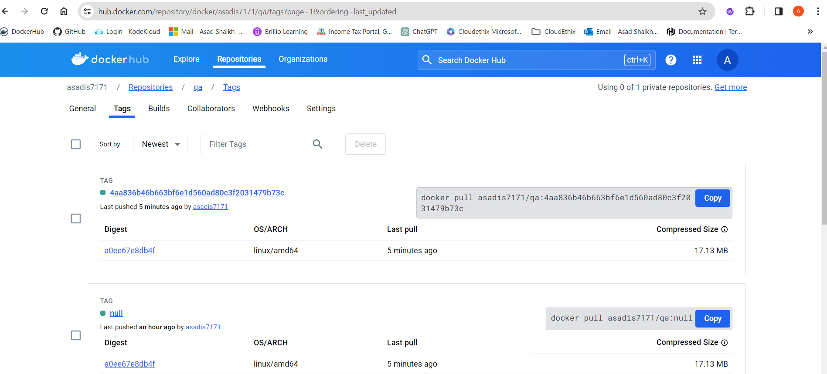

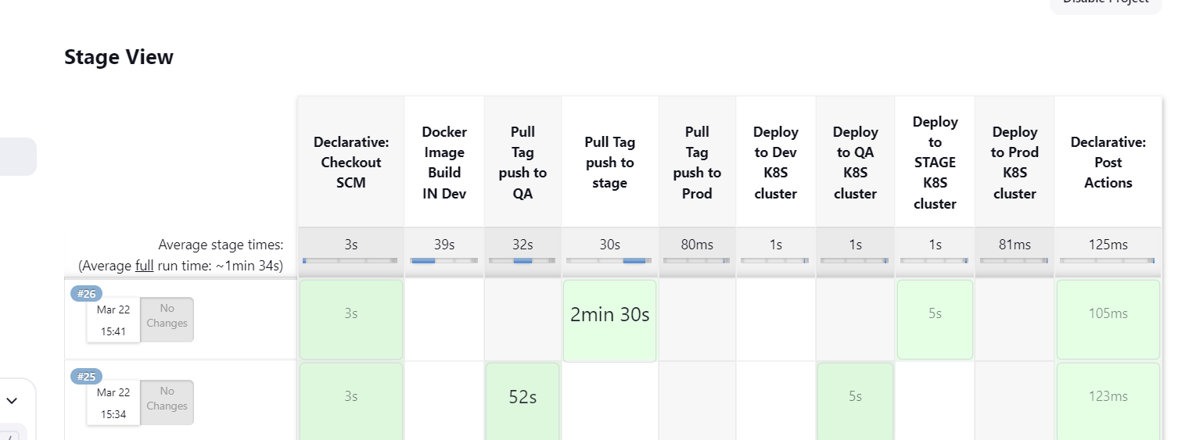

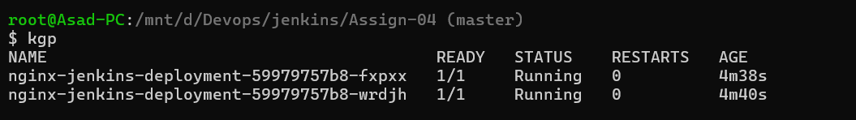

Now running for stage

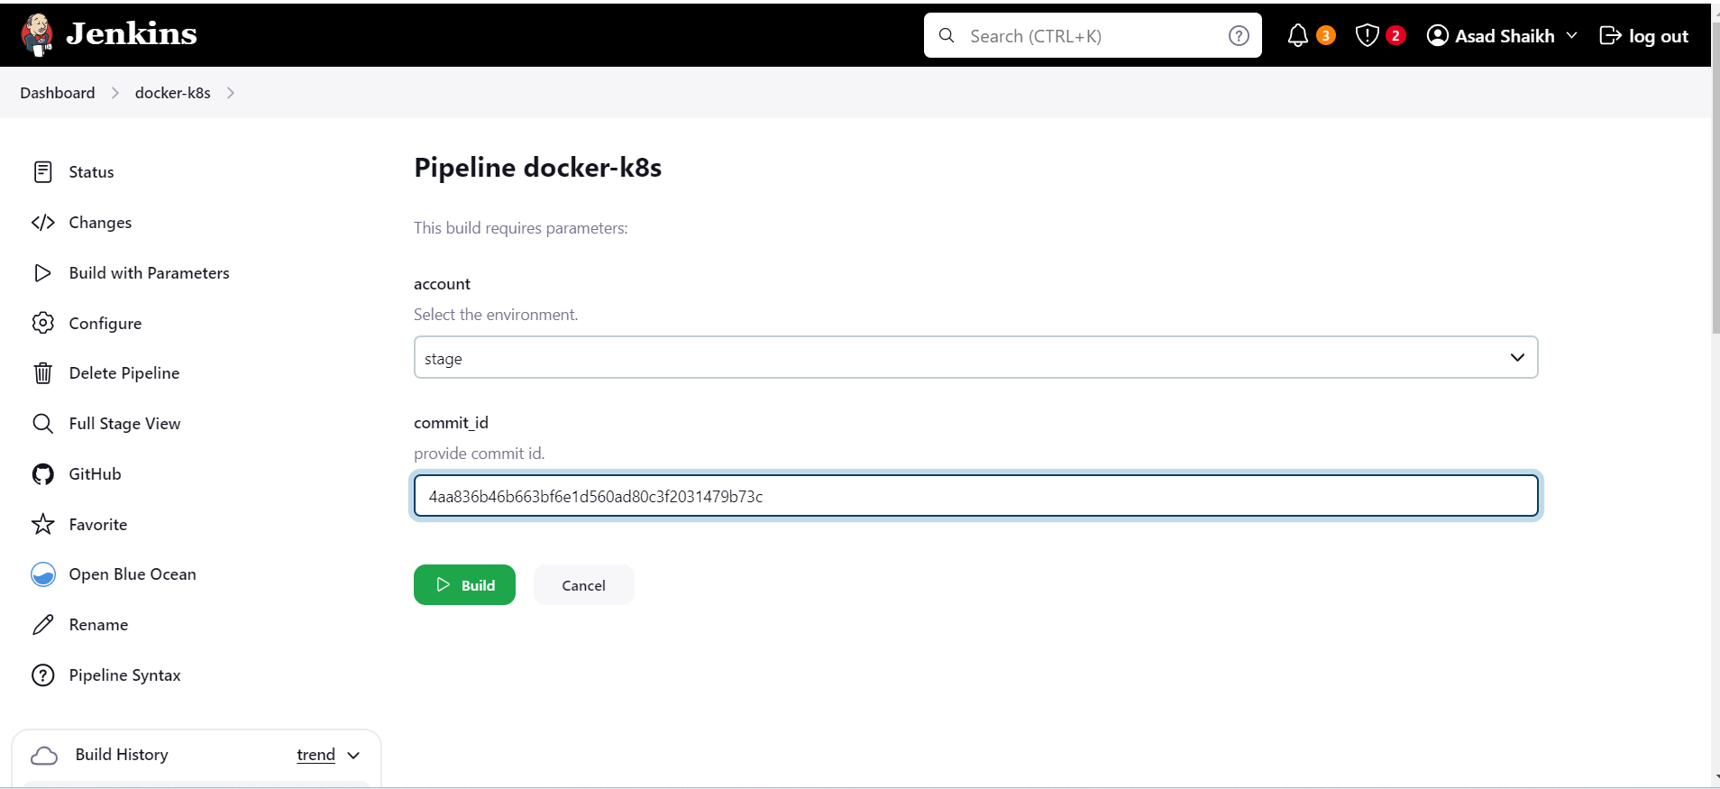

Logs

Started by user [Asad Shaikh](http://localhost:8080/user/admin)

Obtained Jenkinsfile from git git@github.com:asadis7171/jenkins-k8s.git

[Pipeline] Start of Pipeline

[Pipeline] node

Running on [Jenkins](http://localhost:8080/computer/(built-in)/) in /var/jenkins_home/workspace/docker-k8s

[Pipeline] {

[Pipeline] stage

[Pipeline] { (Declarative: Checkout SCM)

[Pipeline] checkout

Selected Git installation does not exist. Using Default

The recommended git tool is: NONE

using credential asad.pem

Cloning the remote Git repository

Cloning repository git@github.com:asadis7171/jenkins-k8s.git

> /usr/bin/git init /var/jenkins_home/workspace/docker-k8s # timeout=10

Fetching upstream changes from git@github.com:asadis7171/jenkins-k8s.git

> /usr/bin/git --version # timeout=10

> git --version # 'git version 2.39.2'

using GIT_SSH to set credentials my private key

Verifying host key using known hosts file

> /usr/bin/git fetch --tags --force --progress -- git@github.com:asadis7171/jenkins-k8s.git +refs/heads/*:refs/remotes/origin/* # timeout=10

> /usr/bin/git config remote.origin.url git@github.com:asadis7171/jenkins-k8s.git # timeout=10

> /usr/bin/git config --add remote.origin.fetch +refs/heads/*:refs/remotes/origin/* # timeout=10

Avoid second fetch

> /usr/bin/git rev-parse refs/remotes/origin/master^{commit} # timeout=10

Checking out Revision 4aa836b46b663bf6e1d560ad80c3f2031479b73c (refs/remotes/origin/master)

> /usr/bin/git config core.sparsecheckout # timeout=10

> /usr/bin/git checkout -f 4aa836b46b663bf6e1d560ad80c3f2031479b73c # timeout=10

Commit message: " added PDF file"

> /usr/bin/git rev-list --no-walk 4aa836b46b663bf6e1d560ad80c3f2031479b73c # timeout=10

[Pipeline] }

[Pipeline] // stage

[Pipeline] withEnv

[Pipeline] {

[Pipeline] withEnv

[Pipeline] {

[Pipeline] stage

[Pipeline] { (Docker Image Build IN Dev)

Stage "Docker Image Build IN Dev" skipped due to when conditional

[Pipeline] }

[Pipeline] // stage

[Pipeline] stage

[Pipeline] { (Pull Tag push to QA)

Stage "Pull Tag push to QA" skipped due to when conditional

[Pipeline] }

[Pipeline] // stage

[Pipeline] stage

[Pipeline] { (Pull Tag push to stage)

[Pipeline] script

[Pipeline] {

[Pipeline] withEnv

[Pipeline] {

[Pipeline] withDockerRegistry

Using the existing docker config file.Removing blacklisted property: auths$ docker login -u asadis7171 -p ******** <https://registry.hub.docker.com/asadis7171/qa>

WARNING! Using --password via the CLI is insecure. Use --password-stdin.

WARNING! Your password will be stored unencrypted in /var/jenkins_home/workspace/docker-k8s@tmp/b069db90-8a11-4cbd-888d-5d77172d4d23/config.json.

Configure a credential helper to remove this warning. See

<https://docs.docker.com/engine/reference/commandline/login/#credentials-store>

Login Succeeded

[Pipeline] {

[Pipeline] isUnix

[Pipeline] withEnv

[Pipeline] {

[Pipeline] sh

+ docker pull registry.hub.docker.com/asadis7171/qa:4aa836b46b663bf6e1d560ad80c3f2031479b73c

4aa836b46b663bf6e1d560ad80c3f2031479b73c: Pulling from asadis7171/qa

Digest: sha256:a0ee67e8db4f1c702a6a588cfb9916bfc1a1ed37f091af10d9d799a7a3ae641e

Status: Image is up to date for registry.hub.docker.com/asadis7171/qa:4aa836b46b663bf6e1d560ad80c3f2031479b73c

registry.hub.docker.com/asadis7171/qa:4aa836b46b663bf6e1d560ad80c3f2031479b73c

[Pipeline] }

[Pipeline] // withEnv

[Pipeline] }

[Pipeline] // withDockerRegistry

[Pipeline] }

[Pipeline] // withEnv

[Pipeline] sh

+ echo Image pulled from QA

Image pulled from QA

[Pipeline] sh

+ echo Tagging Docker image from QA to Stage

Tagging Docker image from QA to Stage

[Pipeline] sh

+ docker tag registry.hub.docker.com/asadis7171/qa:4aa836b46b663bf6e1d560ad80c3f2031479b73c registry.hub.docker.com/asadis7171/stage:4aa836b46b663bf6e1d560ad80c3f2031479b73c

[Pipeline] withEnv

[Pipeline] {

[Pipeline] withDockerRegistry

Using the existing docker config file.Removing blacklisted property: auths$ docker login -u asadis7171 -p ******** <https://registry.hub.docker.com/asadis7171/stage>

WARNING! Using --password via the CLI is insecure. Use --password-stdin.

WARNING! Your password will be stored unencrypted in /var/jenkins_home/workspace/docker-k8s@tmp/d9e4efe7-5205-45a8-9fcf-ac52a0ba8439/config.json.

Configure a credential helper to remove this warning. See

<https://docs.docker.com/engine/reference/commandline/login/#credentials-store>

Login Succeeded

[Pipeline] {

[Pipeline] isUnix

[Pipeline] withEnv

[Pipeline] {

[Pipeline] sh

+ docker tag registry.hub.docker.com/asadis7171/stage:4aa836b46b663bf6e1d560ad80c3f2031479b73c registry.hub.docker.com/asadis7171/stage:4aa836b46b663bf6e1d560ad80c3f2031479b73c

[Pipeline] }

[Pipeline] // withEnv

[Pipeline] isUnix

[Pipeline] withEnv

[Pipeline] {

[Pipeline] sh

+ docker push registry.hub.docker.com/asadis7171/stage:4aa836b46b663bf6e1d560ad80c3f2031479b73c

The push refers to repository [registry.hub.docker.com/asadis7171/stage]

80fd5dd35c9c: Preparing

69a57b78b0ee: Preparing

13c52683b537: Preparing

337b7d64083b: Preparing

cdd311f34c29: Preparing

3e8ad8bcb0ac: Preparing

74b4ff8dbbd1: Preparing

c018a48a857c: Preparing

0f73163669d4: Preparing

aedc3bda2944: Preparing

74b4ff8dbbd1: Waiting

c018a48a857c: Waiting

0f73163669d4: Waiting

aedc3bda2944: Waiting

3e8ad8bcb0ac: Waiting

13c52683b537: Mounted from asadis7171/qa

69a57b78b0ee: Mounted from asadis7171/qa

cdd311f34c29: Mounted from asadis7171/qa

337b7d64083b: Mounted from asadis7171/qa

80fd5dd35c9c: Mounted from asadis7171/qa

74b4ff8dbbd1: Mounted from asadis7171/qa

c018a48a857c: Mounted from asadis7171/qa

3e8ad8bcb0ac: Mounted from asadis7171/qa

aedc3bda2944: Mounted from asadis7171/qa

0f73163669d4: Mounted from asadis7171/qa

4aa836b46b663bf6e1d560ad80c3f2031479b73c: digest: sha256:a0ee67e8db4f1c702a6a588cfb9916bfc1a1ed37f091af10d9d799a7a3ae641e size: 2403

[Pipeline] }

[Pipeline] // withEnv

[Pipeline] }

[Pipeline] // withDockerRegistry

[Pipeline] }

[Pipeline] // withEnv

[Pipeline] sh

+ echo Image Pushed to STAGE

Image Pushed to STAGE

[Pipeline] }

[Pipeline] // script

[Pipeline] }

[Pipeline] // stage

[Pipeline] stage

[Pipeline] { (Pull Tag push to Prod)

Stage "Pull Tag push to Prod" skipped due to when conditional

[Pipeline] }

[Pipeline] // stage

[Pipeline] stage

[Pipeline] { (Deploy to Dev K8S cluster )

Stage "Deploy to Dev K8S cluster " skipped due to when conditional

[Pipeline] }

[Pipeline] // stage

[Pipeline] stage

[Pipeline] { (Deploy to QA K8S cluster )

Stage "Deploy to QA K8S cluster " skipped due to when conditional

[Pipeline] }

[Pipeline] // stage

[Pipeline] stage

[Pipeline] { (Deploy to STAGE K8S cluster )

[Pipeline] withEnv

[Pipeline] {

[Pipeline] script

[Pipeline] {

[Pipeline] echo

Deploying on Stage K8S Cluster.

[Pipeline] withKubeConfig

[Pipeline] {

[Pipeline] sh

+ sed -i -e s/{{ACCOUNT}}/stage/g -e s/{{COMMITID}}/4aa836b46b663bf6e1d560ad80c3f2031479b73c/g KUBE/deployment.yaml

[Pipeline] sh

+ echo deployment.yaml file after replace with sed

deployment.yaml file after replace with sed

[Pipeline] sh

+ cat KUBE/deployment.yaml

apiVersion: apps/v1

kind: Deployment

metadata:

name: nginx-jenkins-deployment

spec:

replicas: 2

selector:

matchLabels:

app: nginx-jenkins

template:

metadata:

labels:

app: nginx-jenkins

spec:

containers:

- name: nginx-jenkins-c

image: asadis7171/stage:4aa836b46b663bf6e1d560ad80c3f2031479b73c

ports:

- containerPort: 80

[Pipeline] sh

+ kubectl apply -f KUBE/deployment.yaml

deployment.apps/nginx-jenkins-deployment configured

[Pipeline] sh

+ kubectl apply -f KUBE/service.yaml

service/frontend-service unchanged

[Pipeline] }

[kubernetes-cli] kubectl configuration cleaned up

[Pipeline] // withKubeConfig

[Pipeline] }

[Pipeline] // script

[Pipeline] }

[Pipeline] // withEnv

[Pipeline] }

[Pipeline] // stage

[Pipeline] stage

[Pipeline] { (Deploy to Prod K8S cluster )

Stage "Deploy to Prod K8S cluster " skipped due to when conditional

[Pipeline] }

[Pipeline] // stage

[Pipeline] stage

[Pipeline] { (Declarative: Post Actions)

[Pipeline] echo

Deleting Workspace from shared Lib

[Pipeline] deleteDir

[Pipeline] }

[Pipeline] // stage

[Pipeline] }

[Pipeline] // withEnv

[Pipeline] }

[Pipeline] // withEnv

[Pipeline] }

[Pipeline] // node

[Pipeline] End of Pipeline

Finished: SUCCESS

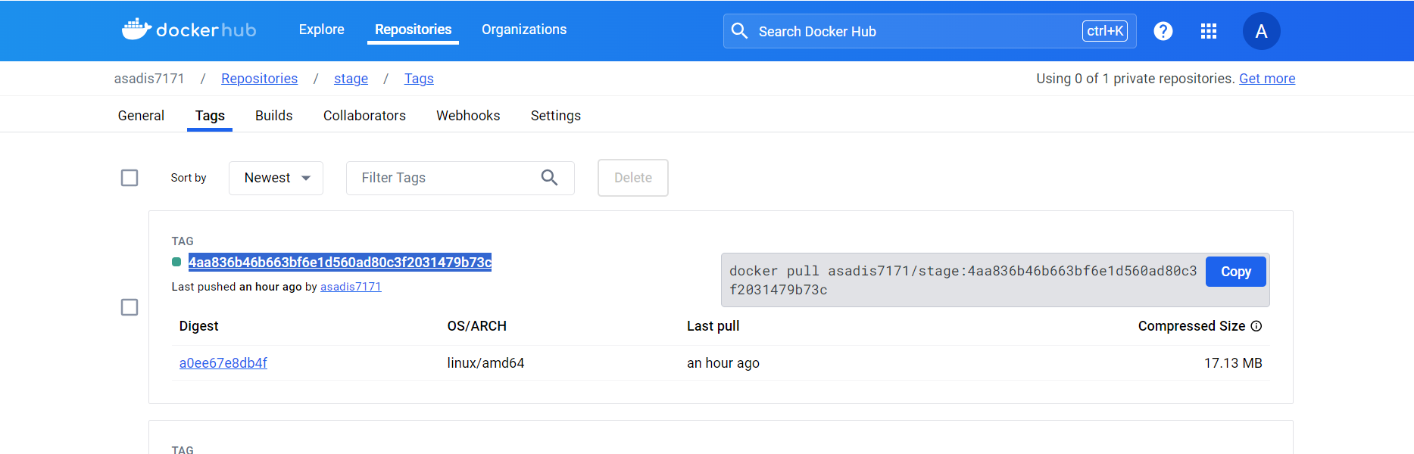



Now running for prod

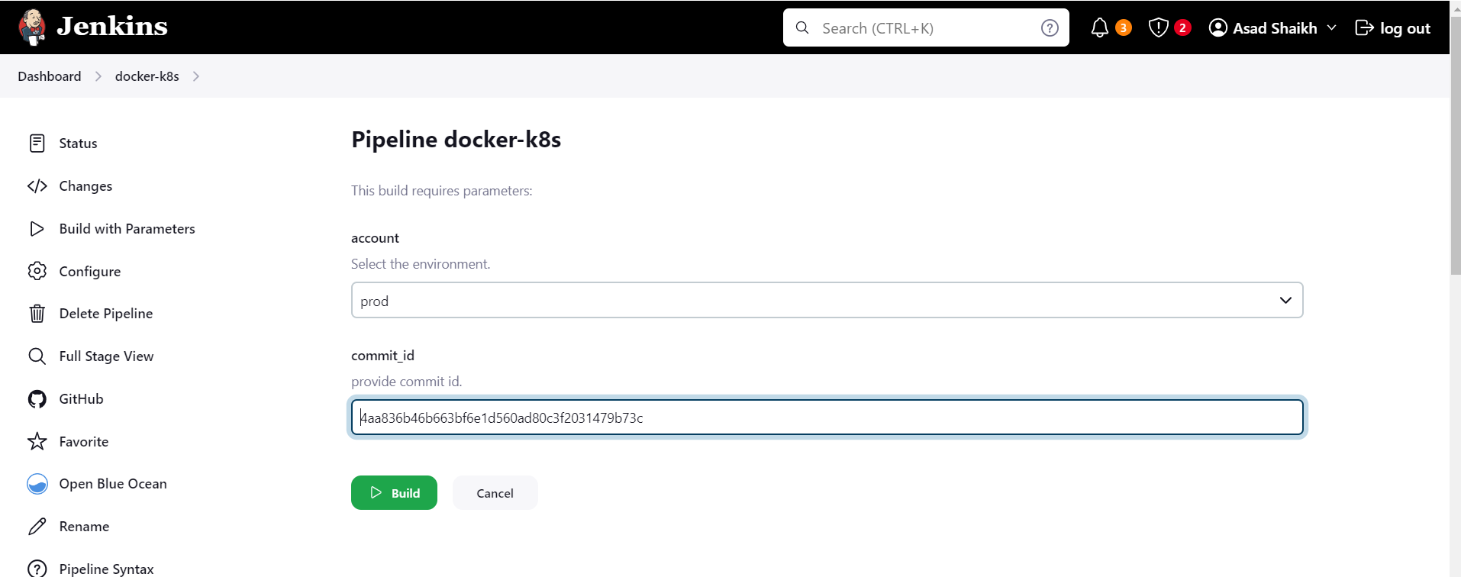

Logs

Started by user [Asad Shaikh](http://localhost:8080/user/admin)

Obtained Jenkinsfile from git git@github.com:asadis7171/jenkins-k8s.git

[Pipeline] Start of Pipeline

[Pipeline] node

Running on [Jenkins](http://localhost:8080/computer/(built-in)/) in /var/jenkins_home/workspace/docker-k8s

[Pipeline] {

[Pipeline] stage

[Pipeline] { (Declarative: Checkout SCM)

[Pipeline] checkout

Selected Git installation does not exist. Using Default

The recommended git tool is: NONE

using credential asad.pem

Cloning the remote Git repository

Cloning repository git@github.com:asadis7171/jenkins-k8s.git

> /usr/bin/git init /var/jenkins_home/workspace/docker-k8s # timeout=10

Fetching upstream changes from git@github.com:asadis7171/jenkins-k8s.git

> /usr/bin/git --version # timeout=10

> git --version # 'git version 2.39.2'

using GIT_SSH to set credentials my private key

Verifying host key using known hosts file

> /usr/bin/git fetch --tags --force --progress -- git@github.com:asadis7171/jenkins-k8s.git +refs/heads/*:refs/remotes/origin/* # timeout=10

> /usr/bin/git config remote.origin.url git@github.com:asadis7171/jenkins-k8s.git # timeout=10

> /usr/bin/git config --add remote.origin.fetch +refs/heads/*:refs/remotes/origin/* # timeout=10

Avoid second fetch

> /usr/bin/git rev-parse refs/remotes/origin/master^{commit} # timeout=10

Checking out Revision 4aa836b46b663bf6e1d560ad80c3f2031479b73c (refs/remotes/origin/master)

> /usr/bin/git config core.sparsecheckout # timeout=10

> /usr/bin/git checkout -f 4aa836b46b663bf6e1d560ad80c3f2031479b73c # timeout=10

Commit message: " added PDF file"

> /usr/bin/git rev-list --no-walk 4aa836b46b663bf6e1d560ad80c3f2031479b73c # timeout=10

[Pipeline] }

[Pipeline] // stage

[Pipeline] withEnv

[Pipeline] {

[Pipeline] withEnv

[Pipeline] {

[Pipeline] stage

[Pipeline] { (Docker Image Build IN Dev)

Stage "Docker Image Build IN Dev" skipped due to when conditional

[Pipeline] }

[Pipeline] // stage

[Pipeline] stage

[Pipeline] { (Pull Tag push to QA)

Stage "Pull Tag push to QA" skipped due to when conditional

[Pipeline] }

[Pipeline] // stage

[Pipeline] stage

[Pipeline] { (Pull Tag push to stage)

Stage "Pull Tag push to stage" skipped due to when conditional

[Pipeline] }

[Pipeline] // stage

[Pipeline] stage

[Pipeline] { (Pull Tag push to Prod)

[Pipeline] script

[Pipeline] {

[Pipeline] withEnv

[Pipeline] {

[Pipeline] withDockerRegistry

Using the existing docker config file.Removing blacklisted property: auths$ docker login -u asadis7171 -p ******** <https://registry.hub.docker.com/asadis7171/stage>

WARNING! Using --password via the CLI is insecure. Use --password-stdin.

WARNING! Your password will be stored unencrypted in /var/jenkins_home/workspace/docker-k8s@tmp/19f31071-c55f-4ff4-b812-1722535f190a/config.json.

Configure a credential helper to remove this warning. See

<https://docs.docker.com/engine/reference/commandline/login/#credentials-store>

Login Succeeded

[Pipeline] {

[Pipeline] isUnix

[Pipeline] withEnv

[Pipeline] {

[Pipeline] sh

+ docker pull registry.hub.docker.com/asadis7171/stage:4aa836b46b663bf6e1d560ad80c3f2031479b73c

4aa836b46b663bf6e1d560ad80c3f2031479b73c: Pulling from asadis7171/stage

Digest: sha256:a0ee67e8db4f1c702a6a588cfb9916bfc1a1ed37f091af10d9d799a7a3ae641e

Status: Image is up to date for registry.hub.docker.com/asadis7171/stage:4aa836b46b663bf6e1d560ad80c3f2031479b73c

registry.hub.docker.com/asadis7171/stage:4aa836b46b663bf6e1d560ad80c3f2031479b73c

[Pipeline] }

[Pipeline] // withEnv

[Pipeline] }

[Pipeline] // withDockerRegistry

[Pipeline] }

[Pipeline] // withEnv

[Pipeline] sh

+ echo Image pulled from QA

Image pulled from QA

[Pipeline] sh

+ echo Tagging Docker image from stage to prod

Tagging Docker image from stage to prod

[Pipeline] sh

+ docker tag registry.hub.docker.com/asadis7171/stage:4aa836b46b663bf6e1d560ad80c3f2031479b73c registry.hub.docker.com/asadis7171/prod:4aa836b46b663bf6e1d560ad80c3f2031479b73c

[Pipeline] withEnv

[Pipeline] {

[Pipeline] withDockerRegistry

Using the existing docker config file.Removing blacklisted property: auths$ docker login -u asadis7171 -p ******** <https://registry.hub.docker.com/asadis7171/prod>

WARNING! Using --password via the CLI is insecure. Use --password-stdin.

WARNING! Your password will be stored unencrypted in /var/jenkins_home/workspace/docker-k8s@tmp/118f0884-5e8e-4e67-9571-36f8133670e3/config.json.

Configure a credential helper to remove this warning. See

<https://docs.docker.com/engine/reference/commandline/login/#credentials-store>

Login Succeeded

[Pipeline] {

[Pipeline] isUnix

[Pipeline] withEnv

[Pipeline] {

[Pipeline] sh

+ docker tag registry.hub.docker.com/asadis7171/prod:4aa836b46b663bf6e1d560ad80c3f2031479b73c registry.hub.docker.com/asadis7171/prod:4aa836b46b663bf6e1d560ad80c3f2031479b73c

[Pipeline] }

[Pipeline] // withEnv

[Pipeline] isUnix

[Pipeline] withEnv

[Pipeline] {

[Pipeline] sh

+ docker push registry.hub.docker.com/asadis7171/prod:4aa836b46b663bf6e1d560ad80c3f2031479b73c

The push refers to repository [registry.hub.docker.com/asadis7171/prod]

80fd5dd35c9c: Preparing

69a57b78b0ee: Preparing

13c52683b537: Preparing

337b7d64083b: Preparing

cdd311f34c29: Preparing

3e8ad8bcb0ac: Preparing

74b4ff8dbbd1: Preparing

c018a48a857c: Preparing

0f73163669d4: Preparing

aedc3bda2944: Preparing

0f73163669d4: Waiting

aedc3bda2944: Waiting

3e8ad8bcb0ac: Waiting

74b4ff8dbbd1: Waiting

c018a48a857c: Waiting

cdd311f34c29: Mounted from asadis7171/stage

69a57b78b0ee: Mounted from asadis7171/stage

337b7d64083b: Mounted from asadis7171/stage

13c52683b537: Mounted from asadis7171/stage

80fd5dd35c9c: Mounted from asadis7171/stage

3e8ad8bcb0ac: Mounted from asadis7171/stage

74b4ff8dbbd1: Mounted from asadis7171/stage

0f73163669d4: Mounted from asadis7171/stage

c018a48a857c: Mounted from asadis7171/stage

aedc3bda2944: Mounted from asadis7171/stage

4aa836b46b663bf6e1d560ad80c3f2031479b73c: digest: sha256:a0ee67e8db4f1c702a6a588cfb9916bfc1a1ed37f091af10d9d799a7a3ae641e size: 2403

[Pipeline] }

[Pipeline] // withEnv

[Pipeline] }

[Pipeline] // withDockerRegistry

[Pipeline] }

[Pipeline] // withEnv

[Pipeline] sh

+ echo Image Pushed to Prod

Image Pushed to Prod

[Pipeline] }

[Pipeline] // script

[Pipeline] }

[Pipeline] // stage

[Pipeline] stage

[Pipeline] { (Deploy to Dev K8S cluster )

Stage "Deploy to Dev K8S cluster " skipped due to when conditional

[Pipeline] }

[Pipeline] // stage

[Pipeline] stage

[Pipeline] { (Deploy to QA K8S cluster )

Stage "Deploy to QA K8S cluster " skipped due to when conditional

[Pipeline] }

[Pipeline] // stage

[Pipeline] stage

[Pipeline] { (Deploy to STAGE K8S cluster )

Stage "Deploy to STAGE K8S cluster " skipped due to when conditional

[Pipeline] }

[Pipeline] // stage

[Pipeline] stage

[Pipeline] { (Deploy to Prod K8S cluster )

[Pipeline] withEnv

[Pipeline] {

[Pipeline] script

[Pipeline] {

[Pipeline] echo

Deploying on Prod K8S Cluster.

[Pipeline] withKubeConfig

[Pipeline] {

[Pipeline] sh

+ sed -i -e s/{{ACCOUNT}}/prod/g -e s/{{COMMITID}}/4aa836b46b663bf6e1d560ad80c3f2031479b73c/g KUBE/deployment.yaml

[Pipeline] sh

+ echo deployment.yaml file after replace with sed

deployment.yaml file after replace with sed

[Pipeline] sh

+ cat KUBE/deployment.yaml

apiVersion: apps/v1

kind: Deployment

metadata:

name: nginx-jenkins-deployment

spec:

replicas: 2

selector:

matchLabels:

app: nginx-jenkins

template:

metadata:

labels:

app: nginx-jenkins

spec:

containers:

- name: nginx-jenkins-c

image: asadis7171/prod:4aa836b46b663bf6e1d560ad80c3f2031479b73c

ports:

- containerPort: 80

[Pipeline] sh

+ kubectl apply -f KUBE/deployment.yaml

deployment.apps/nginx-jenkins-deployment configured

[Pipeline] sh

+ kubectl apply -f KUBE/service.yaml

service/frontend-service unchanged

[Pipeline] }

[kubernetes-cli] kubectl configuration cleaned up

[Pipeline] // withKubeConfig

[Pipeline] }

[Pipeline] // script

[Pipeline] }

[Pipeline] // withEnv

[Pipeline] }

[Pipeline] // stage

[Pipeline] stage

[Pipeline] { (Declarative: Post Actions)

[Pipeline] echo

Deleting Workspace from shared Lib

[Pipeline] deleteDir

[Pipeline] }

[Pipeline] // stage

[Pipeline] }

[Pipeline] // withEnv

[Pipeline] }

[Pipeline] // withEnv

[Pipeline] }

[Pipeline] // node

[Pipeline] End of Pipeline

Finished: SUCCESS

